Body Image
Body Types & Eating Disorders
Body Image
- Refers to the mental picture an individual has of his/herself
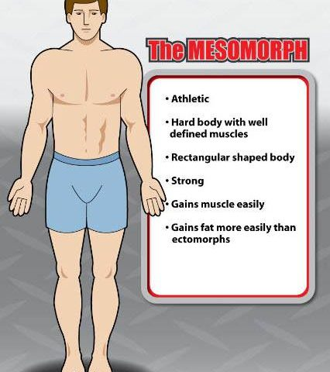
Healthy Body Image
- Involves having a greater appreciation for oneself and others!
- Accepting certain aspects of one’s body structure and shape that are genetic and cannot be changed.
Body Types are determined by genetics
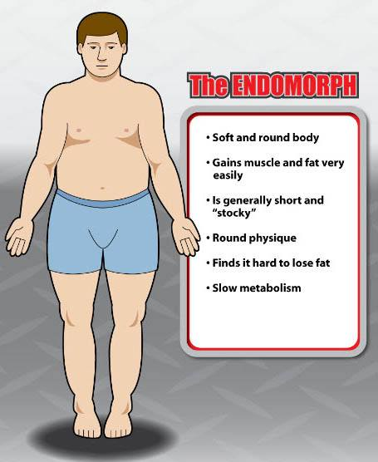
- Mesomorph
  - Wide shoulders
  - Narrow hips
  - Long, round muscle bellies
  - Thinner joints
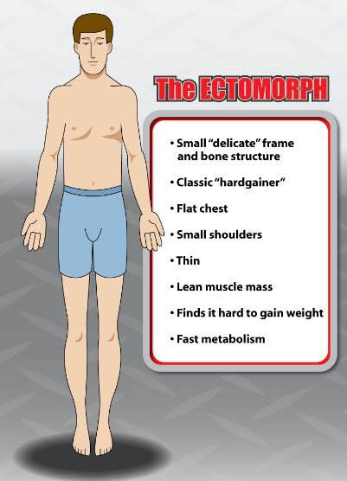
- Endomorph
  - Thicker joints
  - Thick rib cage
  - Hips are wider than shoulders
  - Shorter limbs
- Ectomorph
  - Narrow shoulders and hips
  - Small joints
  - Thin build
  - Long limbs with stringy muscle bellies
Eating Disorders
- Eating disorders are not just about food. They are often a way to cope with difficult problems or regain a sense of control. They are complicated illnesses that affect a person’s sense of identity, worth, and self-esteem (Canadian Mental Health Association).

Muscle Dysmorphia
- a psychological disorder marked by a negative body image and an obsessive desire to have a muscular physique.
It is characterized by
- Excessive time and over-exertion in weightlifting to increase muscle mass  - Preoccupation and panicking over workout if unable to attend  - Overtraining or training when injured  - Disordered eating, using special diets or excessive protein supplements  - Steroid abuse and often other substance misuse | - Distress if exposed leading to camouflage the body  - Compulsive comparing and checking of one’s physique  - Significant distress or mood swings  - Prioritizing one’s schedule over all else or interference in relationships and ability to work

Bulimia Nervosa
- Binge eating conflicted by wanting to lose weight or be thin
- Often leads to forceful vomiting, excessive dieting, or fasting.
Signs and Symptoms
- Calluses or scars on the knuckles or hands from sticking fingers down the throat to induce vomiting.
- Puffy “chipmunk” cheeks caused by repeated vomiting.
- Discolored teeth from exposure to stomach acid when throwing up. May look yellow, ragged, or clear.
- Not underweight – Men and women with bulimia are usually normal weight or slightly overweight. Being underweight while purging might indicate a purging type of anorexia.
- Frequent fluctuations in weight – Weight may fluctuate by 10 pounds or more due to alternating episodes of bingeing and purging.
Effects
- Weight gain  - Dehydration  - Abdominal pain, bloating  - Swelling of the hands and feet  - Chronic sore throat, hoarseness | - Broken blood vessels in the eyes  - Swollen cheeks and salivary glands  - Weakness and dizziness  - Tooth decay and mouth sores | - Acid reflux or ulcers  - Ruptured stomach or esophagus  - Loss of menstrual periods  - Chronic constipation from laxative abuse

Anorexia Nervosa
- Refusal to maintain healthy body weight, Intense fear of gaining weight, and a distorted body image
Signs and Symptoms
- Dieting despite being thin – Following a severely restricted diet. Eating only certain low-calorie foods. Banning “bad” foods such as carbohydrates and fats.
- Obsession with calories, fat grams, and nutrition – Reading food labels, measuring and weighing portions, keeping a food diary, reading diet books.
- Pretending to eat or lying about eating – Hiding, playing with, or throwing away food to avoid eating. Making excuses to get out of meals (“I had a huge lunch” or “My stomach isn’t feeling good.”).
Effects
-Severe mood swings; depression  - Lack of energy and weakness  - Slowed thinking; poor memory | - Constipation and bloating  - Tooth decay and gum damage  - Dry, yellowish skin and brittle nails | - Dizziness, fainting, and headaches  - Growth of fine hair all over the body and face

Binge Eating Disorder
- Frequent episodes of uncontrollable binge eating.
- Feeling extremely distressed or upset during or after bingeing.
- Unlike bulimia, there are no regular attempts to “make up” for the binges through vomiting, fasting, or over-exercising.
Signs and Symptoms
- Inability to stop eating or control what you’re eating
- Rapidly eating large amounts of food
- Eating even when you're full
Effects
- Type 2 diabetes  - Gallbladder disease  - High cholesterol  - High blood pressure | - Heart disease  - Certain types of cancer  - Osteoarthritis | - Joint and muscle pain  - Gastrointestinal problems  - Sleep apnea

Body Image
Body Types & Eating Disorders
Body Image
- ______________________________________________________________________________
Healthy Body Image
- Involves having a greater appreciation for oneself and others!
- Accepting certain aspects of one’s body structure and shape that are genetic and cannot be changed.
Body Types are determined by genetics
- _______________________
  - _______________________
  - _______________________
  - Long, round muscle bellies
  - Thinner joints
- _______________________
  - _______________________
  - _______________________
  - Hips are wider than shoulders
  - Shorter limbs
- _______________________
  - _______________________
  - Small joints
  - _______________________
  - Long limbs with stringy muscle bellies
Eating Disorders
- Eating disorders are not just about food. They are often a way to ___________ with difficult problems or regain a sense of control. They are ______________________ that affect a person’s sense of identity, worth, and self-esteem (Canadian Mental Health Association).

Muscle Dysmorphia
____________________________________________________________________________________________________________________________________________________________________________________________________
- ___________________________________________ ___________________________________________  - Preoccupation and panicking over workout if unable to attend  - Overtraining or training when injured  - Disordered eating, using special diets or excessive protein supplements  - Steroid abuse and often other substance misuse | - Distress if exposed leading to camouflage the body  - Compulsive comparing and checking of one’s physique  - Significant distress or mood swings  - Prioritizing one’s schedule over all else or interference in relationships and ability to work

Bulimia Nervosa
- ________________________________________________________________________________________
- Often leads to forceful vomiting, excessive dieting, or fasting.
Signs and Symptoms
- Calluses or scars on the knuckles or hands from sticking fingers down the throat to induce vomiting.
- Puffy “chipmunk” cheeks caused by repeated vomiting.
- Discolored teeth from exposure to stomach acid when throwing up. May look yellow, ragged, or clear.
- Not underweight – Men and women with bulimia are usually normal weight or slightly overweight. Being underweight while purging might indicate a purging type of anorexia.
- Frequent fluctuations in weight – Weight may fluctuate by 10 pounds or more due to alternating episodes of bingeing and purging.
Effects
- _________________________  - _________________________  - Abdominal pain, bloating  - Swelling of the hands and feet  - Chronic sore throat, hoarseness | - Broken blood vessels in the eyes  - Swollen cheeks and salivary glands  - Weakness and dizziness  - Tooth decay and mouth sores | - Acid reflux or ulcers  - Ruptured stomach or esophagus  - Loss of menstrual periods  - Chronic constipation from laxative abuse

Anorexia Nervosa
- Refusal to maintain healthy body weight, Intense fear of gaining weight, and a distorted body image
Signs and Symptoms
- Dieting despite being thin – Following a severely restricted diet. Eating only certain low-calorie foods. Banning “bad” foods such as carbohydrates and fats.
- Obsession with calories, fat grams, and nutrition – Reading food labels, measuring and weighing portions, keeping a food diary, reading diet books.
- Pretending to eat or lying about eating – Hiding, playing with, or throwing away food to avoid eating. Making excuses to get out of meals (“I had a huge lunch” or “My stomach isn’t feeling good.”).
Effects
-______________________________  - Lack of energy and weakness  - Slowed thinking; poor memory | - Constipation and bloating  - Tooth decay and gum damage  - Dry, yellowish skin and brittle nails | - Dizziness, fainting, and headaches  - Growth of fine hair all over the body and face

Binge Eating Disorder
- ________________________________________________________________________________________
- Feeling extremely distressed or upset during or after bingeing.
- Unlike bulimia, there are no regular attempts to “make up” for the binges through vomiting, fasting, or over-exercising.
Signs and Symptoms
- Inability to stop eating or control what you’re eating
- Rapidly eating large amounts of food
- Eating even when you're full
Effects
- ______________________  - Gallbladder disease  - High cholesterol  - ______________________ | - Heart disease  - Certain types of cancer  - Osteoarthritis | - Joint and muscle pain  - Gastrointestinal problems  - Sleep apnea

